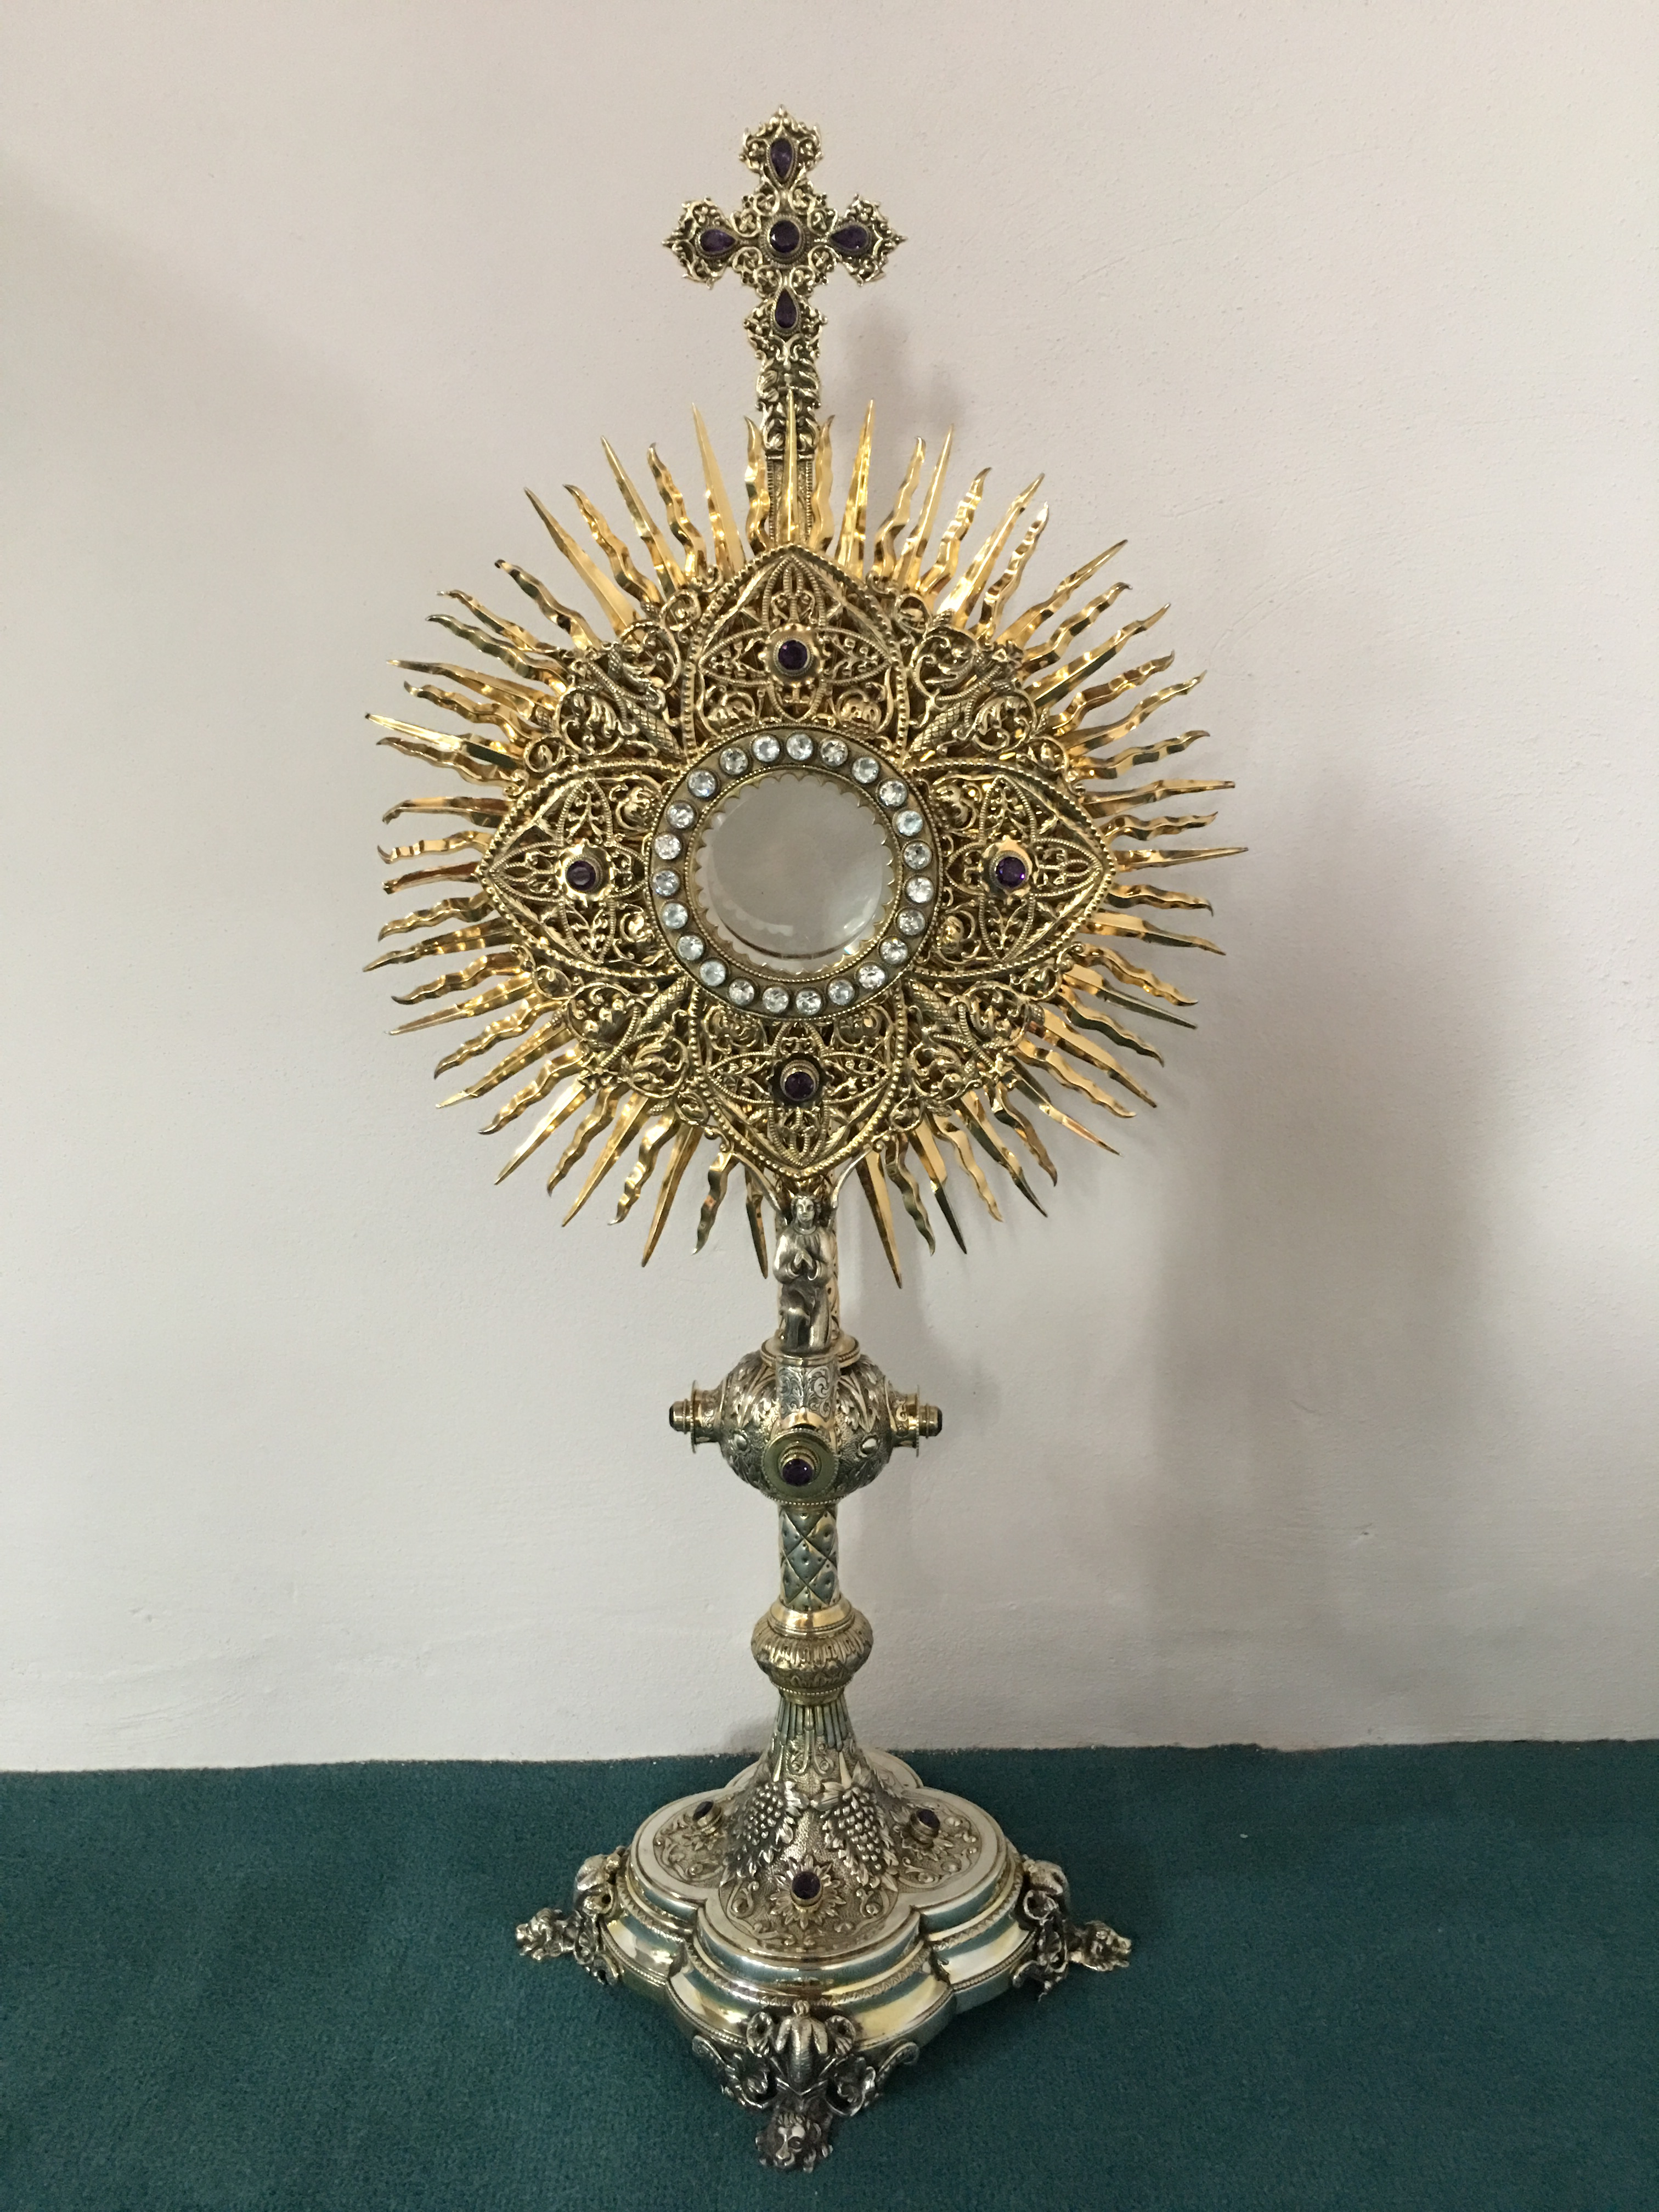
EUCHARISTIC ADORATION
The Parish of Hannahstown News
St Peter’s Church - Every Friday from 2 pm – 8.30 pm
- Every evening from 6.30 pm – 7.30 pm

St Joseph’s Church - Every Tuesday from 5 pm – 7 pm
- Every Wednesday from 9.45 am to 1.45 pm

ANNIVERSARIES:
Daryl Brady, Harry McGowan (1st Anniversary) &
James Philips RIP
RECENT BAPTISMS
Aurora Doran, Fionn Joseph Mallon & Niamh McCorry
We warmly welcome them into our Parish community.

PARISH COLLECTIONS

Many thanks for your generous contributions

27/02/2023 Weekly Collection £1, 092.31

SIGN LANGUAGE CLASSES
The new class will start in May due to requests from participants who are unable to attend until that date. We hope to see you then.

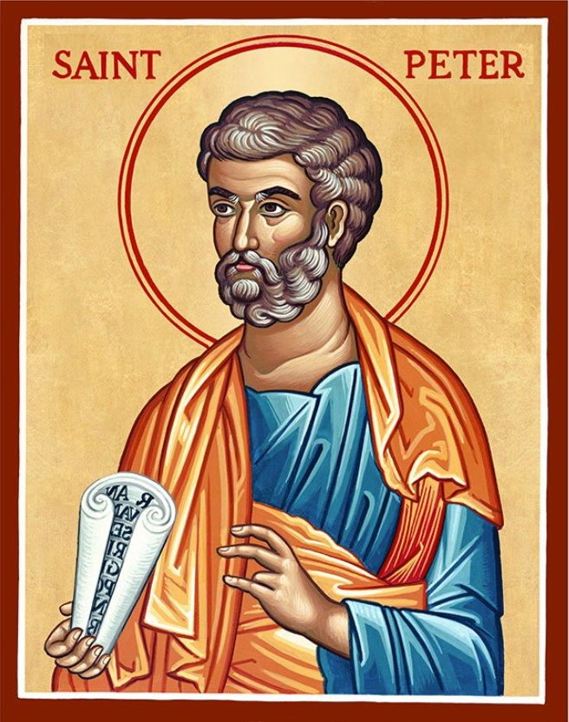
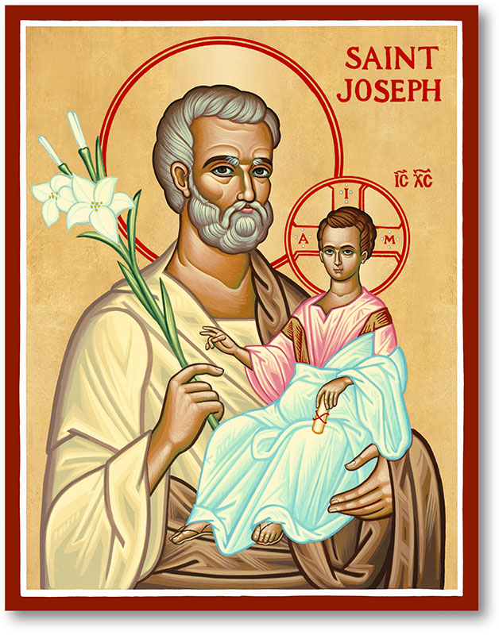
The Parish of Hannahstown
Saint Joseph’s and Saint Peter’s

5th March 2023
Second Sunday of Lent

Vicariate Emergency Sick Calls: 07549209775
Readings: Sunday Cycle A Weekdays 1 Psalter Week 10

Monday 09:15 am (Prayer for Vocations) Saint Joseph’s
Tuesday 7:00pm (Holy Mass for Lent) Saint Joseph’s
Wednesday 09:15am (Novena to Our Lady) Saint Joseph’s
Thursday 09:15am (Parish Novena to Our Lady) Saint Peter’s
Friday 09:15am (Sacred Heart Prayer) Saint Joseph’s
Saturday 6:00pm (St Michael the Archangel Prayer) Saint Joseph’s Sunday 10:00am (Prayer for Pope’s Intentions) Saint Peter’s
Sunday 11:30am (St Joseph Prayer) Saint Joseph’s

Very Reverend Patrick Devlin Parish Priest,
Chaplain to the Deaf Community, Down and Connor Diocese
(For Spiritual & Pastoral needs ONLY, thank you) Tel: 07910 833699
Parish Secretary/email: Mrs Grainne McArevey Tel: 028 90614567 hannahstown@downandconnor.org
The Masses are streamed on the webcam live from St. Joseph’s Church, Hannahstown and St. Peter’s Church, The Rock:
St. Joseph’s - https://churchmedia.tv/st-josephs-church
St. Peter’s https://churchmedia.tv/st-peters-church

Second Sunday of Lent
Jesus took Peter and James and John with him up this mountain because he wanted them to share something of his relationship with God. The risen Jesus wants all his disciples, all of us, to experience God as an enduring, loving, presence on our own life’s journey which invariably becomes at some point a way of the cross. The Gospel reading invites us to leave ourselves open to being touched by God’s grace, God’s goodness and love, so that like Jesus, we can travel hopefully when the way is difficult and we find ourselves struggling with the prospect of loss.

Hannahstown Community Hall

Please contact Anthony Adams for any enquiries on 02890 309795 Mon-Fri 10am – 1pm. hannahstowncentre@btinternet.com
The Parish of Hannahstown Schools
Our primary 3 children will celebrate the Sacrament of Reconciliation on Thursday 9th March in St Peter’s Church. We wish them and their families much joy and many blessings on this special day.

HANNAHSTOWN & THE ROCK PARISH DRAW / FEB 23
Prize  Place | Prize  Money | Name | Number | Collector
1st | £250 | Kenny Jordan | 227 | Raymond Jordan
2nd | £150 | Jim Ferguson | 280 | Jim Ferguson
3rd | £100 | Annie Burns | 298 | Tom McGarrity
4th | £100 | Catherine Reid | 449 | Simon Reid
5th | £50 | Pauline Gorman | 207 | Seamus Armstrong
6th | £50 | Ciara Mathews | 273 | Jim Ferguson
7th | £50 | Dympna Brady | 322 | Irene Phillips
8th | £50 | Mooka Barker | 256 | Jim McCormick
9th | £50 | Bronagh O’Rawe | 166 | Bronagh O’Rawe
10th | £50 | Sinead McCartan | 163 | Maire McKendry
PRAYER

HANNAHSTOWN PARISH LENTEN SPIRITUAL EXERCISES

ST JOSEPH’S CHURCH HANNAHSTOWN
- Tuesday Eucharistic Adoration 5 pm – 7 pm.
- Tuesday 7 pm Holy Mass. 7.30pm – 8.30 pm Jesus of Nazareth film.
- Wednesday Eucharistic Adoration 9.45 am – 1. 45 pm.
ST PETER’S CHURCH THE ROCK
- Evening Prayer every evening with Eucharistic Adoration from 6.30 pm to 7.30 pm. During Adoration the Rosary & Divine Mercy Chaplet will be prayed. You can join us in the Church or via the webcam www.parishofhannahstown.com.
- Friday Adoration 2 pm – 8.30 pm.
FASTING
What to Give Up:
Give up complaining - Focus on gratitude.
Give up harsh judgments - think kindly thoughts.
Give up worry - trust Divine Providence.
Give up bitterness - turn to forgiveness.
Give up anger - be more patient.
Give up sin - turn to virtue.
Give up giving up - hang in there.

ALMSGIVING
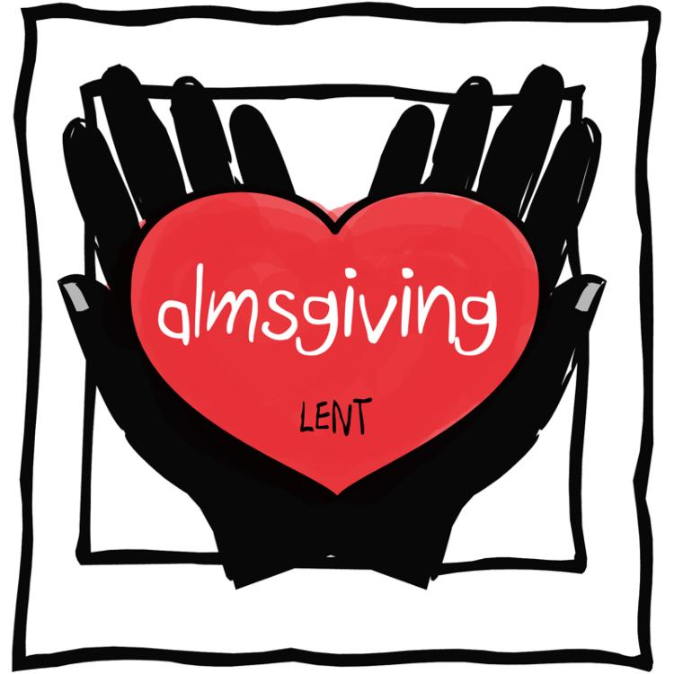
Almsgiving is the act of donating money or goods to the poor or performing other acts of charity. However, when defining almsgiving, it helps to understand the meaning behind the word itself. The roots of the word “alms” can be found in ancient Latin and Greek words meaning mercy and pity.

